CS624 Full-Stack Development Mobile App
PE01 – Hello World
Developed by Sam Chung on February 25, 2022
School of Technology & Computing (STC)
City University of Seattle (CityU)

Before You Start
- You already created a private GitHub repository for all your programming exercises, “cs624-pe-your_first_name.”
- You allowed your instructor and the Teaching Assistant to access your GitHub repository for programming assignments.
- The GitHub Codespaces may bill your account according to your usage. Check the price at https://docs.github.com/en/billing/managing-billing-for-github-codespaces/about-billing-for-github-codespaces. Please pay attention to the storage and core hours of use free of charge for personal accounts.
- Some steps are not explained in the assignment. If you are not sure what to do:
  - Consult the resources listed in your course.
  - If you need help solving the problem after a few tries (~15 minutes), ask a TA for help.

Learning Outcomes
Students will be able to:
  - Create a React Native mobile app using Codespaces, Expo, and Reactive Native.

Problem
Write a “HelloWorld” mobile app that will display your name, degree program, and school with the following constraints:
- User Requirements
  - Text messages in a yellow background color. The text messages show
- System Requirements
  - You can use a total of five React Native components (1 View, 3 Text, and StyleSheet).
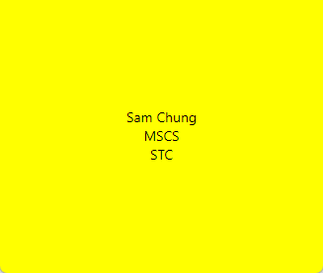
Submission
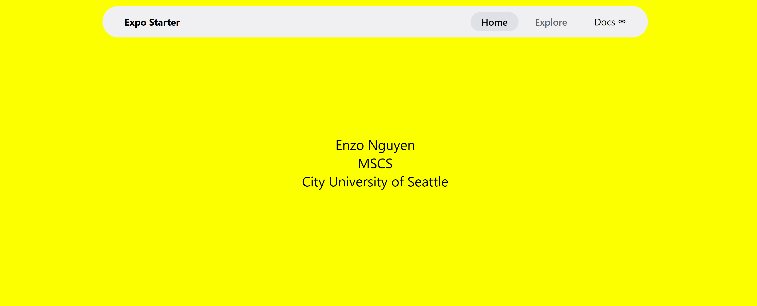
- Create a GitHub repository for your programming exercises. The repository name will be “cs624-pe-your_first_name.”
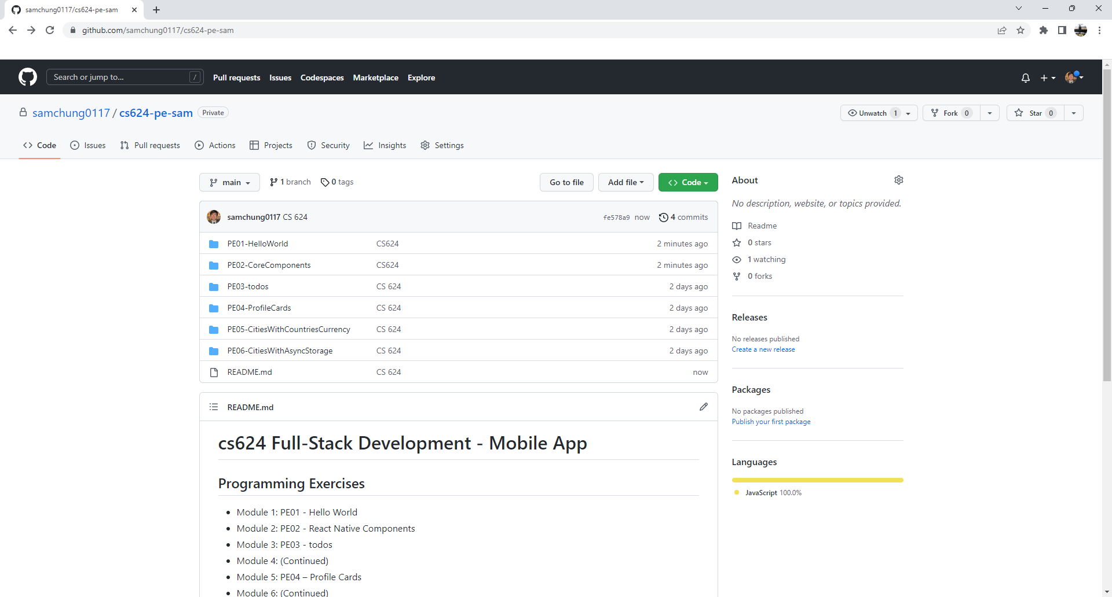
1

- Click the Settings menu. Invite your instructor and TA to collaborators.
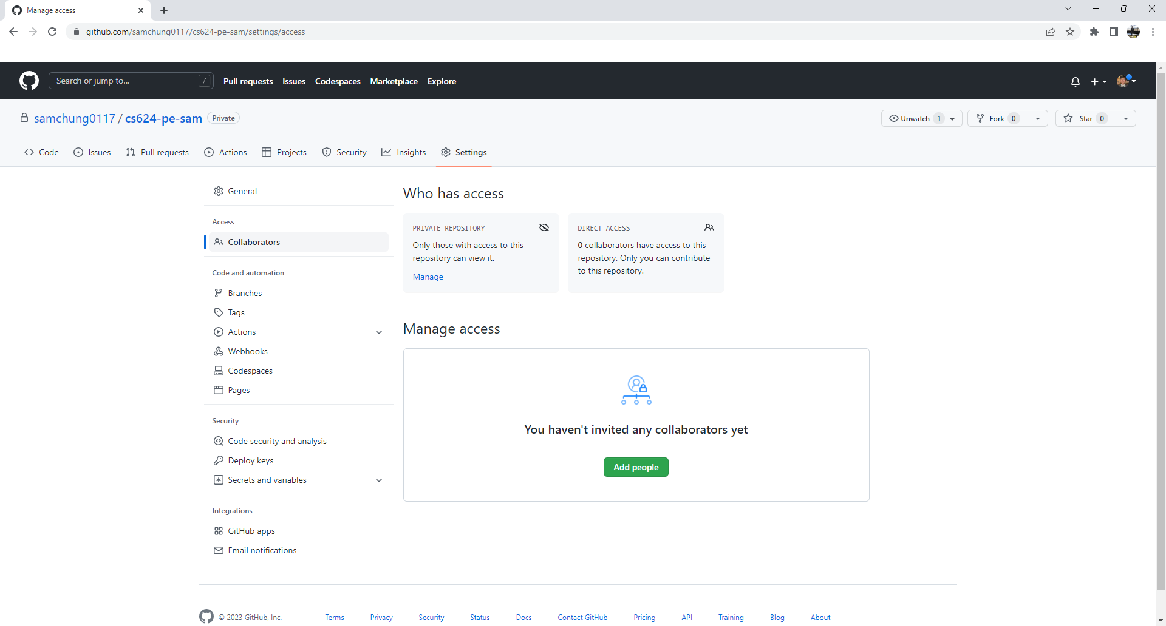
1

- Under the repository, create a directory for the programming exercise 1, “PE01-HelloWorld.” For example, the screen below shows that the following seven directories were created for all programming exercises.
- Finish your programming exercise under the PE01 directory.
- Write a 150-word analysis report to explain how the program works in README.md in terms of the input-process-output model. The README.md has three level-1 headings – Input, Process, and Output.
- Submit the link of your GitHub repository to your course shell through your assignment submission.


